K.R. MANGALAM UNIVERSITY

SCHOOL OF ENGINEERING AND TECHNOLOGY



OPERATING SYSTEMS:
LAB ASSIGNMENT 4
COURSE CODE: ENCS351

SUBMISSION IN THE NAME OF: SIDDHANT JHA

ROLL NUMBER: 2301730219
COURSE: BTECH CSE (AI and ML)
LINK TO GIT REPOSTORY:

https://github.com/siddhantjha313/OPERATING-SYSTEM-LAB-FILES

Task 1: Batch Processing Simulation (Python)
Write a Python script to execute multiple .py files sequentially, mimicking batch processing.
import subprocess scripts= ['scriptl .py', 'script2.py', 'script3.py'] for script in scripts:
print(f'Executing {script}...") subprocess.call(['python3', script])
Executing
Hello
Executing
Hello
Executing
Hello







py.
..

py..
.

Task 2: System Startup and Logging
Simulate system startup using Python by creating multiple processes and logging their start and end into a log file.
import multiprocessing import logging import time logging.basicConfig(filename='system_log.txt', level=logging.INFO,
format='¾(asctime)s - ¾(processName)s - ¾(message)s')
def process_task(name):
logging.info(f'{name} started") time.sleep(2) logging.info(f'{name} terminated")
if name = ' main ':
print("System Booting...") p1 = multiprocessing.Process(target=process_task, args=("Process-1",)) p2 = multiprocessing.Process(target=process_task, args=("Process-2",))
pl.start() p2.start() pl.join() p2.join()
print("System Shutdown.")

starte | d
starte | d
 | d
- Process - Process
- Process - Process
- Process - Process
- Process Process

Task 3: System Calls and IPC (Python - fork, exec, pipe)
Use system calls (forkO, execO, waitO) and implement basic Inter-Process Communication using pipes in C or Python. import os r, w = os.pipe() pid = os.fork() if pid > 0: os.close(r) os.write(w, b"Hello from parent") os.close(w) os.wait() else:
os.close(w) message = os.read(r, 1024) print("Child received:", message.decode()) os.close(r)


  Hello |  | parent

Task 4: VM Detection and Shell Interaction
Create a shell script to print system details and a Python script to detect if the system is running inside a virtual machine.
#!/bin/bash echo "Kernel Version:" uname -r echo "User:" whoami
echo "Hardware Info:" lscpu I grep 'Virtualization'
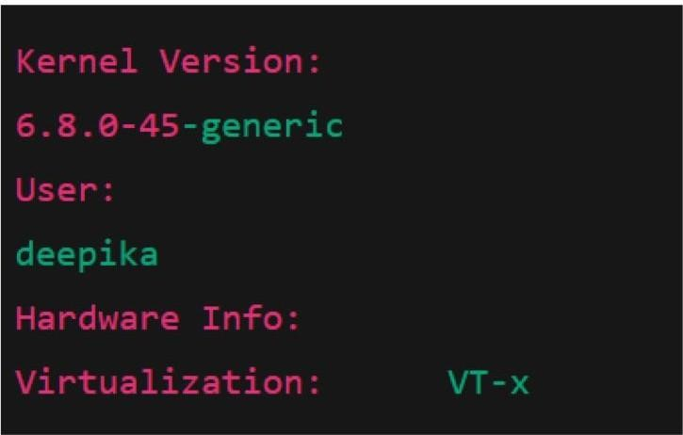

Task 5: CPU Scheduling Algorithms
Implement FCFS, SJF, Round Robin, and Priority Scheduling algorithms in Python to calculate WT and TAT.

Use existing Round Robin, FCFS, SJF, Priority scheduling Python codes from Lab 3)

CPU Scheduling Algorithms

# --------- FCFS Scheduling --------- -

def fcfs(processes):
print("\nFCFS Scheduling:") print("PID\tBT\tWT\tTAT") wt= 0
total wt= 0

total tat= 0

for pid, bt in processes:
tat= wt+ bt print(f'{pid}\t{bt}\t{wt}\t{tat}") total wt += wt total tat += tat wt+= bt print(f' Average Waiting Time: {total_wt/len(processes)}") print(f' Average Turnaround Time: {total_tat/len(processes)}")
# --------- SJF Scheduling (Non-Preemptive) -------- -

def sjf(processes):

processes.sort(key=lambda x: x[l]) # sort by burst time

print("\nSJF Scheduling:") print("PID\tBT\tWT\tTAT")

wt=O

total wt= 0

total tat= 0

for pid, bt in processes:
tat= wt+ bt print(f''{pid}\t{bt}\t{wt}\t{tat}") total wt += wt total tat += tat wt+= bt print(f''Average Waiting Time: {total_wt/len(processes)}") print(f''Average Turnaround Time: {total_tat/len(processes)}")
# --------- Priority Scheduling --------def priority_scheduling(processes):
#processes= [(pid, bt, priority)]

processes.sort(key=lambda x: x[2]) # lower value - higher priority print("\nPriority Scheduling:") print("PID\tBT\tPriority\tWT\tTAT")
wt= 0

total wt= 0

total tat= 0

for pid, bt, pr in processes:
tat= wt+ ht print(f'{pid}\t{bt}\t{pr}\t\t{wt}\t{tat}") total wt += wt total tat += tat wt+= bt print(f' Average Waiting Time: {total_wt/len(processes)}") print(f'Average Turnaround Time: {total_tat/len(processes)}")

# --------- Round Robin Scheduling -------- -

def round_robin(processes, quantum): #processes= [(pid, bt)] rem_bt = [bt for _, bt in processes] t = 0
n = len(processes)

wt= [O] * n tat= [O] * n print("\nRound Robin Scheduling:") print("PID\tBT\tWT\tTAT") while True: done= True
for i in range(n):

if rem bt[i] > 0: done= False ifrem_bt[i] > quantum: t += quantum rem_bt[i] -= quantum
else:
t += rem bt[i]

wt[i] = t - processes[i][l] rem bt[i] = 0
if done:

break

for i in range(n):

tat[i] = wt[i] + processes[i][l] print(f'{processes[i][O]}\t{processes[i][1]}\t{wt[i]}\t{tat[i]}") print(f' Average Waiting Time: {sum(wt)/n}") print(f'Average Turnaround Time: {sum(tat)/n}") n = int(input("Enter number of processes:")) processes_fcfs = [] processes_sjf = [] processes_priority = [] processes_rr = []
for i in range(n):

bt = int(input(f'Enter Burst Time for P{i+1}: "))

pr= int(input(f'Enter Priority for P{i+1} (lower= higher priority): ")) processes_fcfs.append((i+1, bt)) processes_sjf.append((i+1, bt)) processes_priority.append((i+1, bt, pr)) processes_rr.append((i+1, bt)) quantum= int(input("Enter Time Quantum for Round Robin: ")) fcfs(processes_fcfs) sjf(processes_sjf) priority_scheduling(processes_priority) round_robin(processes_rr, quantum)
